Project Development Phase Model Performance Test

|  |  |
| --- | --- |
| Date | 19 November 2022 |
| Team ID | PNT2022TMID14038 |
| Project Name | Exploratory Analysis of Rain Fall Data in India for Agriculture |
| Maximum Marks | 10 Marks |

Model Performance Testing:

Project team shall fill the following information in model performance testing template.

|  |  |  |  |
| --- | --- | --- | --- |
| **S.No.** | **Parameter** | **Values** | **Screenshot** |
| 1. | Metrics | **Classification Model: Random Forest**  **Confusion Matrix –**  **[[21393 1324]**  **[ 2855 3520]]**  **Accuracy Score-**  0.8563522617901829  **Classification Report –** Accuracy: 0.856352261790182  9  Precision: 0.7641309659553673  Recall: 0.49814165870234683  F1-score: 0.6031113396760092 |  |

VISUALIZATION CHARTS:

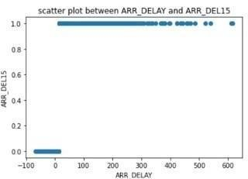

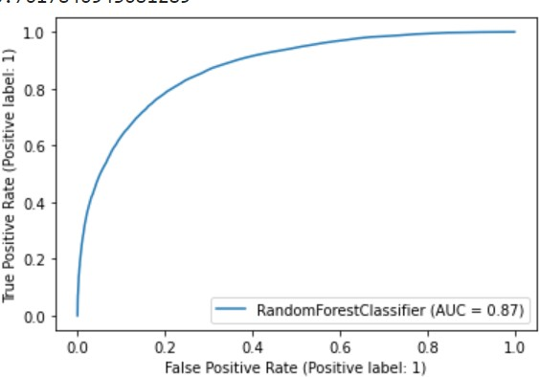**ROC - AUC Curve**

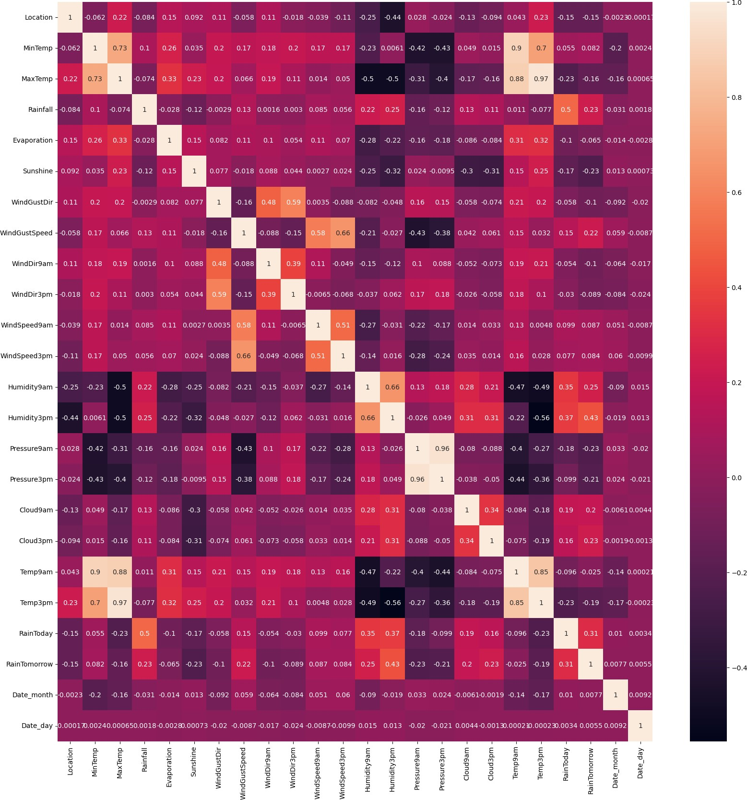**Plot Heat Map**